**Objectives**

1. Research information about software for a specific operating system (OS) environment. You will be assigned one of the operating systems form the list below. You will also be provided with a list of topics to investigate.
2. Organize your rough research information into a list of topics, sub-topics and facts. This process will involve identifying sub-topics, rearranging your rough research notes, and selecting (or highlighting) interesting facts.
3. Report a summary of your research in the form of a “concept map”. Use the PowerPoint template provided as a starting point. The concept map should only include the best and most interesting information from your organized research notes.
4. Your concept map can be created using: Smart Ideas, Prezi, PowerPoint or other similar applications.

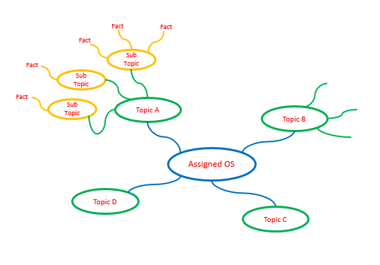

**IBM Operating System**

**z/OS**

**Step 1 – Organized Research**

Research information about your assigned operating system (OS) environment.

* Guide your research according to the suggested topic list below
* Feel free to copy-and-paste as long as you keep track of your bibliographic references.
* Do not be too picky or concerned about formatting as you will organize this information later in step 2
* Select things that look interesting and don’t forget to include graphics images as well
* Upload your rough research notes to your repository when you are done.

<https://www.ibm.com/it-infrastructure/z/zos>

<https://searchdatacenter.techtarget.com/definition/z-OS>

<https://www.ibm.com/support/knowledgecenter/zosbasics/com.ibm.zos.zconcepts/zconc_batchjeses.htm#:~:targetText=Batch%20processing%20is%20for%20those,to%20control%20their%20output%20processing.>

<http://csc.columbusstate.edu/woolbright/zarchitecture.pdf>

<https://www.ibm.com/support/knowledgecenter/zosbasics/com.ibm.zos.zsecurity/zsecurity_book.pdf>

<https://www.ibm.com/support/knowledgecenter/en/SSLTBW_2.1.0/com.ibm.zos.v2r1.idad400/rslvcfl.htm>

<https://www.ibm.com/support/pages/zos-upgrade-and-installation>

<https://www.ibm.com/support/knowledgecenter/zosbasics/com.ibm.zos.znetwork/znetwork_7.htm>

<https://www.ibm.com/support/knowledgecenter/en/SSLTBW_2.3.0/com.ibm.zos.v2r3.idad400/ch4.htm>

<https://www.ibm.com/support/knowledgecenter/zosbasics/com.ibm.zos.znetwork/znetwork_15.htm>

<https://www.ibm.com/support/knowledgecenter/en/SSLTBW_2.1.0/com.ibm.zos.v2r1.idaj100/devref.htm>

Topic A – Application Software

Provide a summary of most important user application software targeted by this operating system and how it is similar to and deferent from standard PC software. Suggested sub-topics include:

* User (client) or network (server) applications

The program was built for servers and so there are no user applications.

Most server applications are to host programming languages and allow there to be a basic srver UI with some advanced tools

* Batch (run without user input) or interactive (user focused) processing

JCL used to control operations

Operations run in parallel

* Off-the-shelf (purchased) or custom developed applications

Java for z/OS, Language environment, Metal C, Node.js, Open Data analytics and z/OS XML are some of the applications for z/OS

* Programming environment and languages supported

Supports Java

Supports assembler applications such as C, C++ and COBOL

Topic B – Hardware

Provide a summary of the hardware targeted by this operating system and how it is similar to and deferent from standard PC hardware. Suggested sub-topics include:

z/OS is meant to be used on mainframe computers

Specifically z/Architecture computers

* Speed of processors / memory

z/Architecture computers use very fast processors in high numbers and have huge amounts of memory.

* Capacity of memory / attached disks

z/Architecture computers can have around 16 EiB of memory.

* Is it designed for home / office / corporate data center / industrial use

It is designed for a corporate data center use.

* Is it designed for client / server / network use?

As a mainframe computer OS it is designed for network use.

Developed by [IBM](https://searchitchannel.techtarget.com/definition/IBM-International-Business-Machines) for its family of z/Architecture enterprise [mainframe](https://searchdatacenter.techtarget.com/definition/mainframe) computers, including the zEnterprise 196 and zEnterprise 114.

64 Bit OS

Topic C – User Interface

Provide a summary of the user interface and input devices targeted by this operating system and how it is similar to and deferent from a standard PC. Suggested sub-topics include:

* Does it support a windowed environment, command line, or network users

z/OS does not support a windowed environment. It supports a command line and can send information between servers.

* Does it support multiple users at a time or single users

z/OS can support multiple users at a time.

* Does it support multiple applications or a single application at a time

z/OS can support multiple applications at once

* Does it get rebooted (powered on / off) or is it always on

It can be powered off but this requires users to stop using the network and is not done often.

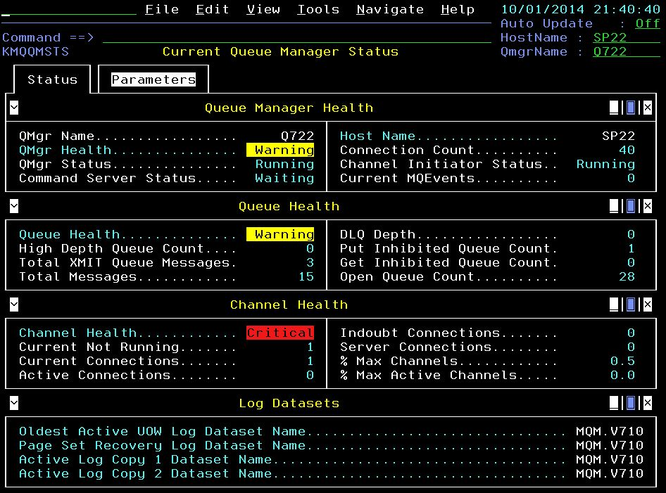

Topic D – Device Management

Provide a summary of the devices (disks, printers, etc.) and memory managed by this operating system and how it is similar to and deferent from a standard PC. Suggested sub-topics include:

* What types of disk drives and file systems does it support

Tape drives, tape volumes, DASD (most other types, Flashdrive, ODD etc…) are supported for z/OS

* What type of input devices does it support

USB devices will work with z/OS for input and output

* What type of output devices does it support

USB devices will work with z/OS for input and output

Topic E – Security

Provide a summary of the security features provided by this operating system and how it is similar to and deferent from a standard PC. Suggested sub-topics include:

* What types of user accounts and user permissions does it support

The z/OS is meant for mainframes so it only needs an administrator account.

* How does it protect against conflicts / interference between legitimate application processes

It puts things into a queue so that they can go one at a time.

* How does it protect against malicious software

It had checks to make sure that some features are blocked behind security authorization requests.

* How does it support software updates and security updates

IBM releases security updates in small packages so that they can be easily downloaded and there has not been a new version for a while.

Topic F – Network Connectivity

Provide a summary of the network connectivity provided by this operating system and how it is similar to and deferent from a standard PC. Suggested sub-topics include:

* Is the computer stand-alone or part of a larger network

The computer runs a larger network but itself does not require other computers to function.

* What type of network and internet connections does it provide

z/OS can connect to any internet and network source. It provides a good connection for servers to use

* Does it provide other services such as backup, firewall, etc.

Provides backup services

Z/OS can provide a firewall but it is not the best for this.

**Step 2 – Concept Map**

Create a “concept map” as a final report of your organized research.

* Use the diagram in the introduction as a starting point.
* You should have six (6) first level topics from “Application Software”   
  to “Network Connectivity”
* Each first level topic should have at least three (3) sub-topics
* Each sub-topic should be supported by a number of facts / items of interest

Select the best and most interesting information from your organized research.

* Summarize and edit your information to fit on the concept map.

Upload your Research Notes and Concept Map to your GitHub Repository

* Your concept map can be created using: Smart Ideas, Prezi, PowerPoint or other   
  similar applications.
* Option1: Create and upload a PDF of your concept map
* Option2: Include a link to your Concept Map in your Student Questions
  + Make sure that your link is Sharable so Mr. Nestor can open your map

**Appendix A**

|  |  |  |
| --- | --- | --- |
| **Operating System** | **Student 1** | **Student 2** |
| Ubuntu  (Linux) |  |  |
| z/OS  (IBM) |  |  |
| Solaris  (Oracle) |  |  |
| HP-UX  (Hewlett Packard) |  |  |
| Windows NT  (Windows Server) |  |  |
| Red Hat Enterprise (IBM Summit) |  |  |
| QNX  (Blackberry) |  |  |
| VxWorks  (Wind River) |  |  |
| AOSP  (Android Alphabet) |  |  |
| Ubuntu  (Linux) |  |  |
| z/OS  (IBM) |  |  |
| Solaris  (Oracle) |  |  |
| HP-UX  (Hewlett Packard) |  |  |
| Windows NT  (Windows Server) |  |  |
| Red Hat Enterprise (IBM Summit) |  |  |
| QNX  (Blackberry) |  |  |
| VxWorks  (Wind River) |  |  |
| AOSP  (Android Alphabet) |  |  |
|  |  |  |
|  |  |  |
|  |  |  |
|  |  |  |